Query to display customer name, product tier cap, data usage, rating plan and usage charges for the customers who exceed their data limit.
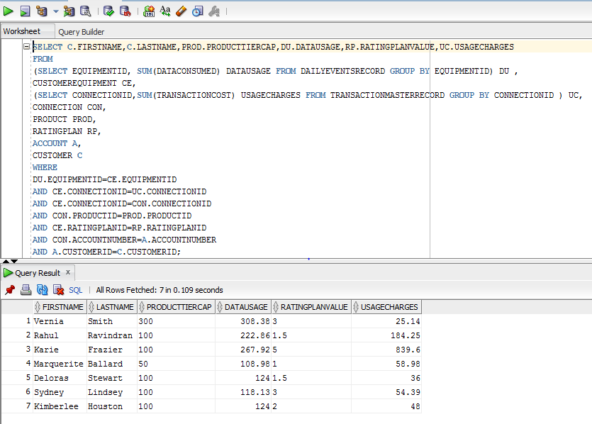

SELECT C.FIRSTNAME, C.LASTNAME, PROD.PRODUCTTIERCAP, DU.DATAUSAGE, RP.RATINGPLANVALUE, UC.USAGECHARGES
FROM
(SELECT EQUIPMENTID, SUM (DATACONSUMED) DATAUSAGE FROM DAILYEVENTSRECORD GROUP BY EQUIPMENTID) DU,
CUSTOMEREQUIPMENT CE,
(SELECT CONNECTIONID, SUM (TRANSACTIONCOST) USAGECHARGES FROM TRANSACTIONMASTERRECORD GROUP BY CONNECTIONID) UC,
CONNECTION CON,
PRODUCT PROD,
RATINGPLAN RP,
ACCOUNT A,
CUSTOMER C
WHERE
DU.EQUIPMENTID=CE.EQUIPMENTID
AND CE.CONNECTIONID=UC.CONNECTIONID
AND CE.CONNECTIONID=CON.CONNECTIONID
AND CON.PRODUCTID=PROD.PRODUCTID
AND CE.RATINGPLANID=RP.RATINGPLANID
AND CON.ACCOUNTNUMBER=A.ACCOUNTNUMBER
AND A.CUSTOMERID=C.CUSTOMERID;

